Unit: Language and knowledge

Knowledge Questions: How does language help us communicate ideas? How does our choice of words affect how our language is interpreted?

NYC Subway Maps

Look over the three maps of the NYC Subway provided to your group. Consider the following questions and take notes in the table provided

- How effective or useful is this map?
- What does each map show? Not show?
- What is emphasized? How does this emphasis show what is valued or not valued?
- Why do familiar ones seem "right" and unfamiliar ones seem "wrong"?
- How do maps distort our views of the world?
- What is the correct view of the NYC subway system?

Map 1 | Map 2 | Map 3
Conclusions

What are the takeaways from the subway map activity? What are the implications?

Respond:

Consider the expression: “The map is not the territory.” What does it mean? Consider it literally but also consider maps as a metaphor for knowledge. Consider the relationship between knowledge of an object and the actual object and how it compares to a map of a place and the actual place.

Knowledge Questions: How are maps an appropriate metaphor for knowledge?

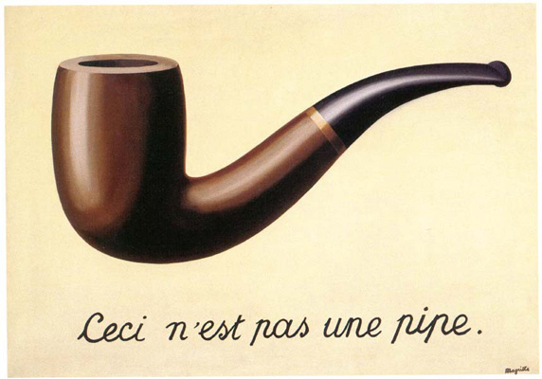
Do Now:
What idea is the artist trying to convey with this painting? Consider the title when responding.

“This is not a pipe”

Magritte, René (1929) La Trahison des images (Ceci n’est pas une pipe) The Treachery of Images (This is not a pipe) Oil on canvas. Los Angeles County Museum of Art.

NYC Subway Maps and Knowledge

Reflect on the work we did last class looking at NYC subway maps along with the artwork above. We said that the “best” map depended on your purpose. Why can there be no “perfect” map?

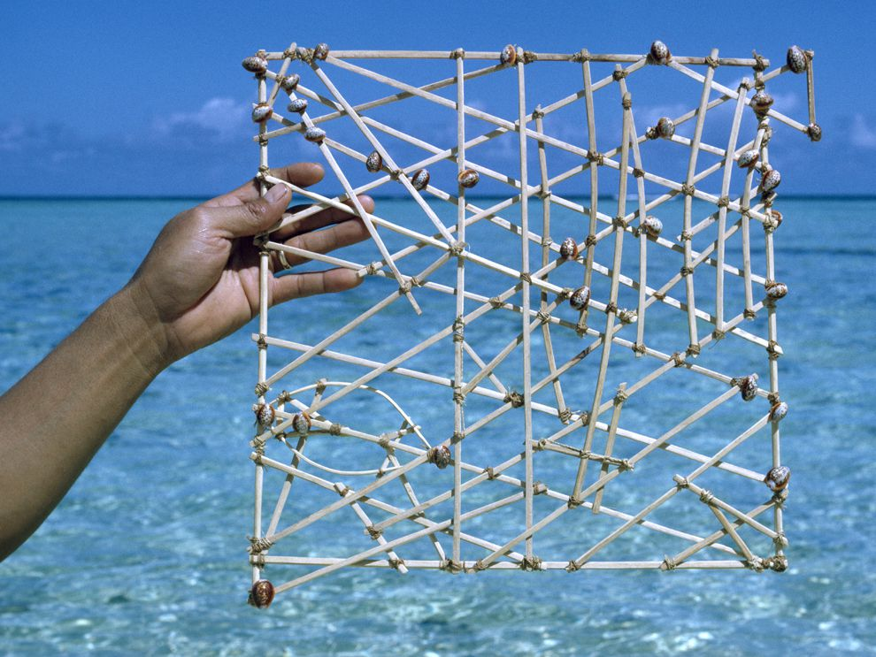
Micronesian Stick Chart

Micronesian stick charts show wave patterns and currents. The shells represent atolls and islands. Using stick charts (also called rebbelibs, medos, and mattangs) ancient mariners successfully navigated thousands of miles of the South Pacific Ocean without compasses, astrolabes, or other mechanical devices. Charts were highly individualized. Sometimes, a stick chart could only be read by the person who made it!

Polynesian settlement of the Pacific

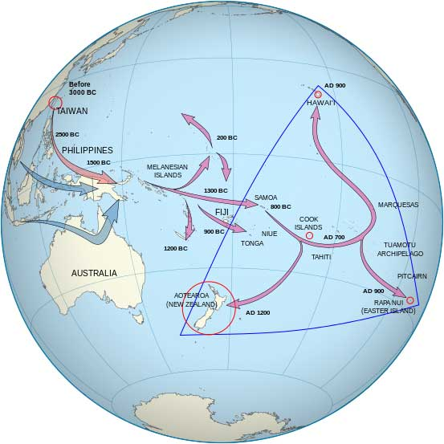
Contrast the Polynesian approach to map making with the European approach. How were they different? Think about how each approach attempts to convey knowledge.

Read and Respond:

The initiator of these observations was the Polish-American scholar Alfred Korybski. He most likely influenced Magritte’s art. Korzybski said, “The Map is Not the Territory”. What he means is that the territory is the world and the map a generalization we use to make sense of it. It also proposes that we don’t have unmediated contact with the external world/reality. Korybski saw that language was at the same time the thing that made possible cultural development of the human race and at the same time the one that harmed it’s perception. When we communicate an experience, we often use generalizations in our words, and those generalizations leave out the things that made that event unique; they leave out the concrete experience, which results in a small abstraction of things out of a whole. Korzybski used various methods to reveal the levels of abstraction in play. One illustration he used in his lectures was to point to a chair and announce, “This is not a chair.” With this he was demonstrating that the word “chair” is not the object where we sit.

“All models are wrong but some are useful.”

“When map and terrain differ, follow the terrain.”

“The map of reality is not reality. Even the best maps are imperfect. That’s because they are reductions of what they represent. If a map were to represent the territory with perfect fidelity, it would no longer be a reduction and thus would no longer be useful to us. A map can also be a snapshot of a point in time, representing something that no longer exists. This is important to keep in mind as we think through problems and make better decisions.”

“The important point is that in our march to simplify reality with useful models we confuse the models with reality. For many people, the model creates its own reality. It is as if the spreadsheet comes to life. We forget that reality is a lot messier. The map isn’t the territory. The theory isn’t what it describes, it’s simply a way we choose to interpret a certain set of information. Maps can also be wrong, but even if they are essentially correct, they are an abstraction, and abstraction means that information is lost to save space. (Recall the mile-to-mile scale map.)

“How do we do better? The first step is to realize that you do not understand a model, map, or reduction unless you understand and respect its limitations. We must always be vigilant by stepping back to understand the context in which a map is useful, and where the cliffs might lie.”

Explain the authors’ ideas in your own words.

Maps and Knowledge Wrap Up

We ran out of time at the end of last class but I wanted to put a fine point on the conversation since it was the culmination of two days of class. When we say, “the map is not the territory” we are talking about the fact that there is the thing itself and the representation of it. Maps are representation of actual, real world, land. Maps have to distort and simplify the complexity of the real world in order to be useful. Maps are not the same as the real things they represent. Remember how a subway map that is more accurately proportional to the actual subway lines and New York City is less useful than the distorted map we are used to seeing. Remember also that a “perfect” representation of the subway system would have to be as complete and detailed as the subway system itself. How useful would that be?

We can extend this to the concept of knowledge. Knowledge exists in human minds. We have to recognize that when we know about a thing it is not the same as the thing itself. My knowledge of the sun is whatever concept of the sun I can hold in my mind. It is not the same as the sun itself. My understanding of the human body cannot possibly be as complicated or detailed as the human body itself but that does not mean I cannot have a “model” or “map” of the human body in my mind. That is a representation of it that can be useful to me but never quite as accurate or detailed as the real thing. We have to recognize that through this process of knowing about things we are simplifying and distorting but this is the best we can do. We have to recognize the limitations of our knowledge and the process of knowing. In each Area of Knowledge, we will explore different concepts, models, and maps relevant to each field and explore how those can be helpful to our understanding but also how they can cause us to come to false understandings and conclusions because we forget that the “map is not the territory.”

http://www.fusionmagazine.org/why-this-is-not-a-pipe/
Adapted from the Farnam Street blog: https://fs.blog/2015/11/map-and-territory/

