Corona Virus “Lab Leak” Theory

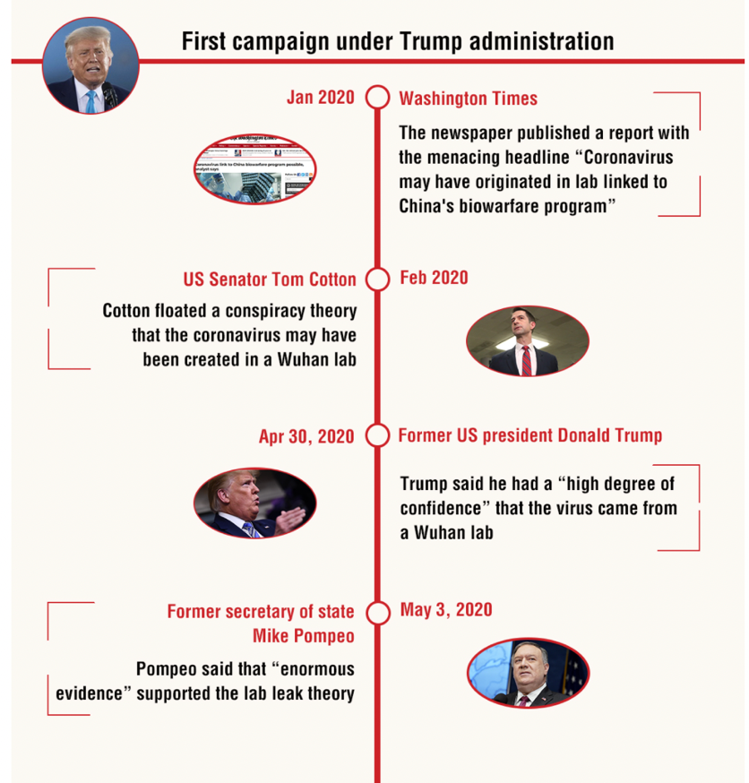
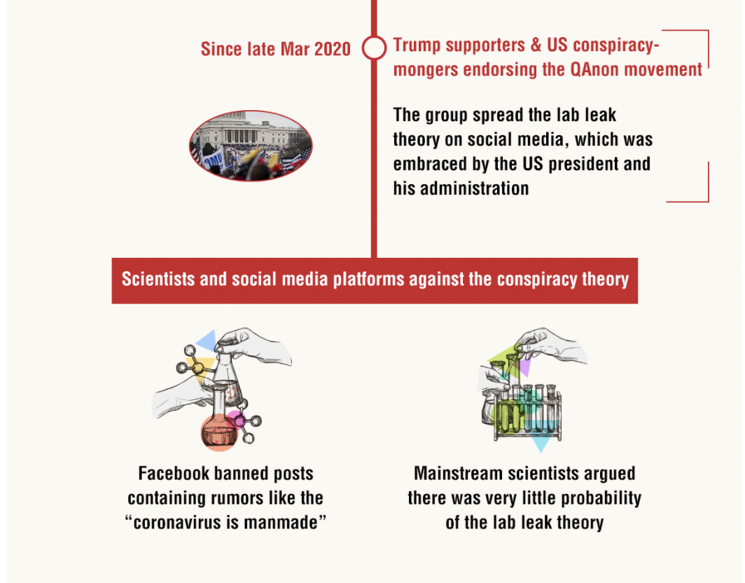

Infographic adapted from: https://www.globaltimes.cn/page/202108/1232445.shtml

The Media's COVID Failure (adapted with sections of “Media Groupthink and the Lab-Leak Theory” by Bret Stephens)

In dismissing the possibility that the virus leaked from a lab, journalists betrayed their mission to seek the truth.

By Zaid Jilani

In February 2020, Senator Tom Cotton, Republican of Arkansas, asked a provocative question: Was there some relationship between COVID-19 emerging in the Chinese city of Wuhan and the fact that there’s a biochemical lab in the city that specializes in studying coronaviruses? Was it possible that this lab was studying an animal that carried the virus and failed to properly secure it?

Rewind the tape to February of last year, when people such as Senator Tom Cotton began pointing to a disturbing fact set: the odd coincidence of a pandemic originating in the same city where a Chinese lab was conducting high-end experiments on bat viruses; the troubling report that some of the original Covid patients had no contact with the food markets where the pandemic supposedly originated; the fact that the Chinese government lied and stonewalled its way through the crisis. Think what you will about the Arkansas Republican, but these were reasonable observations warranting impartial investigation.

The common reaction in elite liberal circles? A Washington Post reporter called it a “fringe theory” that “has been repeatedly disputed by experts.” The Atlantic Council accused Cotton of abetting an “infodemic” by “pushing debunked claim that the novel coronavirus may have been created in a Wuhan lab.” A writer for Vox said it was a “dangerous conspiracy theory” being advanced by conservatives “known to regularly spew nonsense (and bash China).”

Facebook, which has increasingly appointed itself the arbiter [judge, decider] of global speech, had a policy of taking down posts claiming that the virus was man-made or manufactured.

In recent weeks, that has slowly started to change. Top scientists are calling for a more serious probe into the origins of the virus, including the lab-leak theory. President Biden is ordering our intelligence agencies to do a 90-day investigation into the question of where the virus came from. And Facebook recently lifted its ban on posts that claim that the virus that causes COVID-19 was manufactured.

What should we make of all this?

Facebook's concession that the lab leak story it once viewed as demonstrably false is actually possibly true should put to rest the idea that banning or regulating misinformation should be a chief public policy goal.

It appears that for the past year, our media seemed to lock arms in shielding the Chinese government from the scrutiny it deserved for failing to control the virus. Whether or not the lab-leak hypothesis bears out, it is clear that our nation’s journalists did not approach this question with an open mind.

In a tweet that she later deleted, Apoorva Mandavilli, a New York Times science reporter who has been on the coronavirus beat, offered a window into the mindset of much of the media: “Someday we will stop talking about the lab leak theory and maybe even admit its racist roots. But alas, that day is not yet here.”

Is it really supposed to be “racist” to consider the possibility that the Chinese government failed to prevent the virus that causes COVID-19 from escaping from a government lab? The other leading origin theory—that the virus emerged from China's lightly regulated wet markets—would place more of the blame on local culture than the lab-leak hypothesis, which directly implicates the government (and only the government).

Perhaps Mandavilli’s revealing tweet is emblematic of a wider mindset among American journalists, many of whom saw their mission as simply opposing any stance taken by the Trump administration.

Anyone wondering why so many people have become so hostile to the pronouncements of public-health officials and science journalists should draw the appropriate conclusion from this story. When lecturing the public about the dangers of misinformation, it’s best not to peddle it yourself. The goal of journalism shouldn’t be to craft the most culturally sensitive or partisan narrative. The goal of journalism is to seek the truth. The consequences of telling the truth should be secondary to getting the trut
h out there in the first place, even if it makes the Trump administration or Republican Senators look good or the Chinese government look bad.

Respond: What does this story tell us about “fake news,” misinformation, or how people acquire knowledge?

