Unit: Knowledge and the Knower

Knowledge questions: What is the role of intuition in acquiring knowledge? What is the relationship between reason and intuition?

Do Now: Consider the following quote. What is the difference between information and knowledge? Do you agree with the statement?

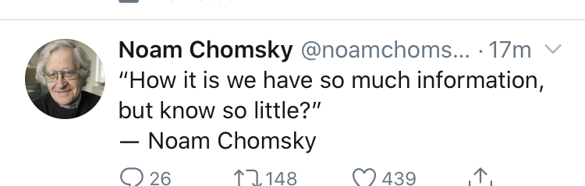

Information: little bits of thoughts, ideas, facts, no context or overarching meaning

Knowledge is formed from information that we give meaning to or make meaning from.

Information can be the raw material of knowledge.

True, false, examples? Easy to get lots of information but hard to know what’s true and what’s false.

Knowledge requires mastery, we have easy access to lots of information from schools, internet, various technologies. Information doesn’t require “truth”

The Statue That Didn’t Look Right
(Adapted from Blink by Malcolm Gladwell)

Directions: As you read pay attention to the connections to any of the course concepts we have covered so far in the class. Connections to knowledge, problems of knowing, truth, how we acquire knowledge, knowledge communities, etc.
In September of 1983, an art dealer by the name of Gianfranco Becchina approached the J. Paul Getty Museum in California. He had in his possession, he said, a marble statue dating from the sixth century BC. It was what is known as a kouros—a sculpture of a nude male youth standing with his left leg forward and his arms at his sides. There are only about two hundred kouroi in existence, and most have been recovered badly damaged or in fragments from grave sites or archeological digs. But this one was almost perfectly preserved. It stood close to seven feet tall. It had a kind of light-colored glow that set it apart from other ancient works. It was an extraordinary find. Becchina’s asking price was just under $10 million.
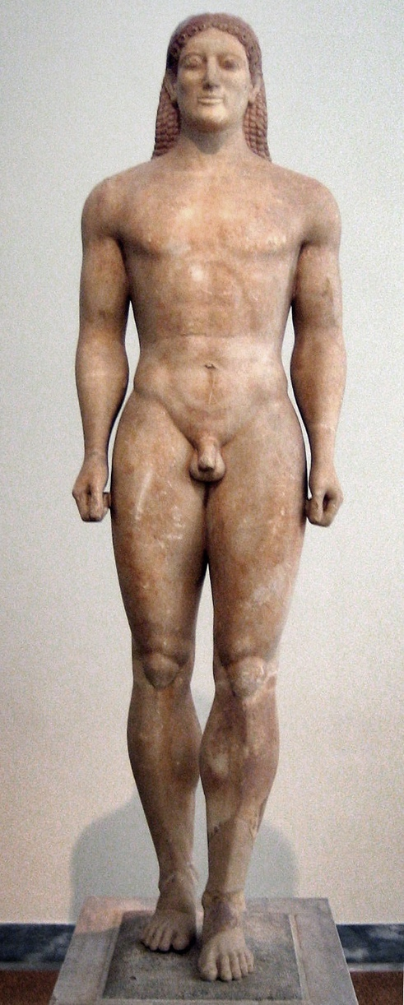
The Getty moved cautiously. It took the kouros on loan and began a thorough investigation. Was the statue consistent with other known kouroi? The answer appeared to be yes. The style of the sculpture seemed reminiscent of the Anavyssos kouros in the National Archaeological Museum of Athens, meaning that it seemed to fit with a particular time and place. Where and when had the statue been found? No one knew precisely, but Becchina gave the Getty’s legal department a sheaf of documents relating to its more recent history. The kouros, the records stated, had been in the private collection of a Swiss physician named Lauffenberger since the 1930s, and he in turn had acquired it from a well-known Greek art dealer named Roussos.
A geologist from the University of California named Stanley Margolis came to the museum and spent two days examining the surface of the statue with a high-resolution stereomicroscope. He then removed a core sample measuring one centimeter in diameter and two centimeters in length from just below the right knee and analyzed it using an electron microscope, electron microprobe, mass spectrometry, X-ray diffraction, and X-ray fluorescence. The statue was made of dolomite marble from the ancient Cape Vathy quarry on the island of Thasos, Margolis concluded, and the surface of the statue was covered in a thin layer of calcite—which was significant, Margolis told the Getty, because dolomite can turn into calcite only over the course of hundreds, if not thousands, of years. In other words, the statue was old. It wasn’t some contemporary fake.
An authentic Kuoros from 530 BC

The Getty was satisfied. Fourteen months after their investigation of the kouros began, they agreed to buy the statue.
The kouros, however, had a problem. It didn’t look right. The first to point this out was an Italian art historian named Federico Zeri, who served on the Getty’s board of trustees. When Zeri was taken down to the museum’s restoration studio to see the kouros in December of 1983, he found himself staring at the sculpture’s fingernails. In a way he couldn’t immediately articulate, they seemed wrong to him. Evelyn Harrison was next. She was one of the world’s foremost experts on Greek sculpture, and she was in Los Angeles visiting the Getty just before the museum finalized the deal with Becchina. “Arthur Houghton, who was then the curator, took us down to see it,” Harrison remembers. “He just swished a cloth off the top of it and said, ‘Well, it isn’t ours yet, but it will be in a couple of weeks.’ And I said, ‘I’m sorry to hear that.’” What did Harrison see? She didn’t know. In that very first moment, when Houghton swished off the cloth, all Harrison had was a hunch, an instinctive sense that something was amiss. A few months later, Houghton took Thomas Hoving, the former director of the MOMA down to the Getty’s conservation studio to see the statue as well. Hoving always makes a note of the first word that goes through his head when he sees something new, and he’ll never forget what that word was when he first saw the kouros. “It was ‘fresh’— ‘fresh,’” Hoving recalls. And “fresh” was not the right reaction to have to a two-thousand-year-old statue. Later, thinking back on that moment, Hoving realized why that thought had popped into his mind: “I had dug in Sicily, where we found bits and pieces of these things. They just don’t come out looking like that. The kouros looked like it had been dipped in the very best caffè latte from Starbucks.”
Hoving turned to Houghton. “Have you paid for this?” Houghton, Hoving remembers, looked stunned. “If you have, try to get your money back,” Hoving said. “If you haven’t, don’t.” The Getty was getting worried, so they convened a special symposium on the kouros in Greece. They wrapped the statue up, shipped it to Athens, and invited the country’s most senior sculpture experts. This time the chorus of dismay was even louder.
Georgios Dontas, head of the Archeological Society in Athens, saw the statue and immediately felt cold. “When I saw the kouros for the first time,” he said, “I felt as though there was a glass between me and the work.” Why did he think it was a fake? Because when he first laid eyes on it, he said, he felt a wave of “intuitive repulsion.” By the time the symposium was over, the consensus among many of the attendees appeared to be that the kouros was not at all what it was supposed to be. The Getty, with its lawyers and scientists and months of painstaking investigation, had come to one conclusion, and some of the world’s foremost experts in Greek sculpture—just by looking at the statue and sensing their own “intuitive repulsion”—had come to another. Who was right?
Questions:

1. What are the two competing ways of acquiring knowledge? Discuss.

2. Do you think the Kouros was real or fake? Explain.

Ways of knowing

Real | Fake
Scientists collecting scientific evidence analyzing scientifically to come to conclusions about the age and composition  (reason) | Art experts’ Intuition based on previous experiences of similar statues, this statue didn’t have the same “feeling”  Intuition can also be a form of reasoning but subconscious and beyond the ability to communicate through words  (intuition)

For a time it wasn’t clear. The kouros was the kind of thing that art experts argued about at conferences. But then, bit by bit, the Getty’s case began to fall apart. The letters the Getty’s lawyers used to carefully trace the kouros back to the Swiss physician Lauffenberger, for instance, turned out to be fakes. One of the letters dated 1952 had a postal code on it that didn’t exist until twenty years later.

Originally the conclusion of long months of research was that the Getty kouros was in the style of the Anavyssos kouros. But that, too, fell into doubt: the closer experts in Greek sculpture looked at it, the more they began to see it as a puzzling pastiche of several different styles from several different places and time periods. The young man’s slender proportions looked a lot like those of the Tenea kouros, which is in a museum in Munich, and his stylized, beaded hair was a lot like that of the kouros in the Metropolitan Museum in New York. His feet, meanwhile, were, if anything, modern. The kouros it most resembled, it turned out, was a smaller, fragmentary statue that was found by a British art historian in Switzerland in 1990. The two statues were cut from similar marble and sculpted in quite similar ways. But the Swiss kouros didn’t come from ancient Greece. It came from a forger’s workshop in Rome in the early 1980s.

And what of the scientific analysis that said that the surface of the Getty kouros could only have aged over many hundreds or thousands of years? Well, it turns out things weren’t that cut and dried. Upon further analysis, another geologist concluded that it might be possible to “age” the surface of a dolomite marble statue in a couple of months using potato mold. In the Getty’s catalogue, there is a picture of the kouros, with the notation “About 530 BC, or modern forgery.”

When Federico Zeri and Evelyn Harrison and Thomas Hoving and Georgios Dontas-and all the others- looked at the kouros and felt an “intuitive repulsion,” they were absolutely right. In the first two seconds of looking-in a single glance-they were able to understand more about the essence of the statue than the team at the Getty was able to understand after fourteen months.

