Lesson Plan on “Smirk Heard ‘Round the World”
(will probably take two class periods)
(display image on board)
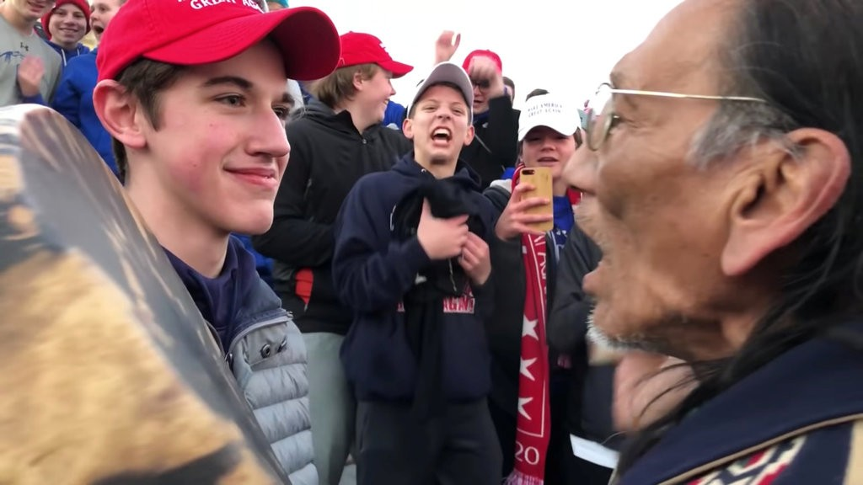

- Do Now:

- Explain the story you think this image is telling.
- What details are your eyes drawn to?
- What WOKs are relevant to your interpretation?
- How does your prior knowledge or prior belief affect how you make sense of this image?

(5 minutes to get started writing)

- Discuss in groups

Share out for a few minutes. (Kids will to some degree be familiar with this case and probably have a larger context than this video but go through the motions and adjust accordingly)

- Watch video

https://www.youtube.com/watch?time_continue=224&v=sIG5ZB0fw1k

(this gets painfully awkward after a while but power through it)

- Revisit the initial story you wrote down

Has your opinion of the situation changed?

Discuss with your groups

- Read clips of articles (attached at the bottom here)

As you read, annotate looking for relevant WOKs being discussed
Pose at least one well worded knowledge question

Discuss at your tables:

What insights do these articles offer about how we acquire knowledge?
What is the role of personal perspective in acquiring knowledge?
What challenges do we face in determining truth?
To what extent can we arrive at the truth in a situation like this?

I Saw the Smirk With My Eyes, But Felt It in My Gut (adapted from Esquire.com)

The world is getting meaner. The teens on the National Mall are symptoms of a larger ailment.

By Dave Holmes

I still see only a howling horde of kids, Tomahawk-chopping and roaring with laughter at a Native American, one smirking young man in the center. I see the same display of unearned, unexamined, vaguely menacing privilege that I did on Saturday.

In the days since the incident on the National Mall, the revelation which is supposed to have changed everything is that Nathan Phillips approached the group of kids, and not the other way around. Who approached whom is only relevant if one 64-year-old man with a single drum is more menacing than a gang of teenage boys. The kids are still cackling at an elder, still mocking him with war whoops. The behavior, in its most generous interpretation, is dishonorable.

The smirk of privilege, framed by MAGA hats and mocking laughter, is all that’s there, despite what the kid in the picture—via the public relations firm his family had the means to retain—says. It is unmistakable, which is why the image was shared as widely as it was. It would not have gone viral if it didn’t resonate, if we hadn’t seen this particular strain of American smirk as long as we’ve had photography.

We’ve seen it on the faces of the white people intimidating black patrons at the Woolworth’s lunch counter, in the pictures of freshly-integrated high schools in Little Rock. We’ve seen it in our own personal histories, if we have ever been that terrifying combination of young and different in any way. We saw that smirk with our eyes, but we felt it in our stomachs.

One reason this experience has been so uncomfortable is that many of us see ourselves in that face. There’s no use pretending I don’t. I grew up in this kind of environment, at this kind of school. That face is me at that age, joining in the abuse of the gayest kid in class, on the days when I managed to work my way to second-gayest. It’s me when I didn’t stop the handful of my high school classmates from chanting, “It’s alright, it’s okay, you’re gonna work for us someday,” at the kids from a poorer high school when they were beating us in basketball. I’ve made this face, I’ve laughed at someone the way these kids laughed at Nathan Phillips, and I have the restless sleep to prove it.

If You Still Think Nick Sandmann’s Smile Is Proof of Racism, You’re Seeing What You Want to See (adapted from Reason.com)

Some are incapable of viewing the MAGA-hat-wearing teens from Covington Catholic as anything other than pure evil.

By Robby Soave

Others have doubled down, offering a variety of explanations for why the new evidence doesn't sway them. Some of this is just goalpost shifting: Maybe Sandmann didn't do anything wrong, but what about the kid who made the tomahawk gesture? An image of Covington Catholic high school students in black body paint at a basketball game in 2012 is somehow supposed to be damaging to Sandmann's credibility, as is the fact that public relations experts reviewed his statement (uh, of course they did).

But the most frustrating and worrying reactions have come from those who have convinced themselves that the extended video footage confirms their initial impressions. Of all the myriad examples of this, perhaps none is more contemptible than the effort by Deadspin's Laura Wagner, who writes, "Don't Doubt What You Saw With Your Own Eyes." Wagner accuses the Covington kids' defenders—me among them—of "siding with some shithead MAGA teens and saying that 2+2=5 in the face of every bit of evidence there is to be had."

But I know what I saw, and I think I know what Wagner saw, too. She saw a group of white teens wearing MAGA hats who had just engaged in partisan political activity on behalf of a cause she opposes (this last detail is more than sufficient on its own to convict the teens, according to several prominent progressive feminists). And that was enough.

How We Destroy Lives Today (adapted from the NYTimes)

Will the Covington Catholic High School fiasco change social media?

By David Brooks

In this one episode, you had a gentle, 64-year-old Native American man being swarmed by white (boo!), male (boo!), preppy (double boo!) Trump supporters (infinite boo!). If you are trying to rub the pleasure centers of a liberal audience, this is truly a story too good to check. Saturday was a day of liberal vindication. See! This is what those people do! This is who they really are.

On Sunday several longer videos emerged showing that most of what Phillips had told the media was inaccurate. The incident actually started when members of the hate cult — the Black Hebrew Israelites — started hurling racist and homophobic slurs at the boys.

So Sunday was a day of conservative vindication. See? This is what those liberals do! They rush to judgment, dehumanize and seek to expunge us from national life. The main boy wrote a public letter that was consistent with the visual evidence and that was actually quite humane.

In this technology, stereotype is more salient than persons. In this technology, a single moment is more important than a life story. In this technology, a main activity is proving to the world that your type is morally superior to the other type.

https://www.esquire.com/news-politics/a25966711/nick-sandmann-smirk/
https://reason.com/blog/2019/01/22/nick-sandmann-covington-catholic-racism
https://www.nytimes.com/2019/01/21/opinion/covington-march-for-life.html?ref=oembed

