Can You Read People’s Emotions?

For each photo, choose the word that best describes what you think the person depicted is thinking or feeling.

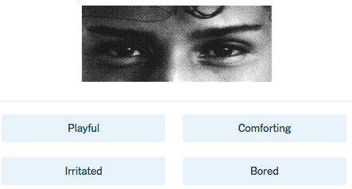

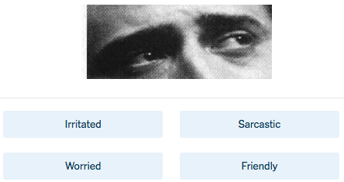

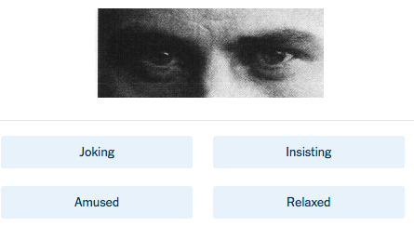

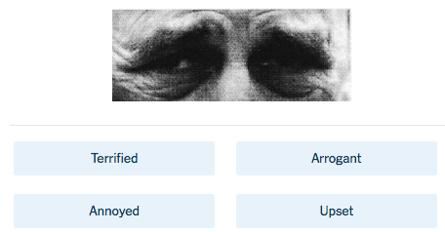
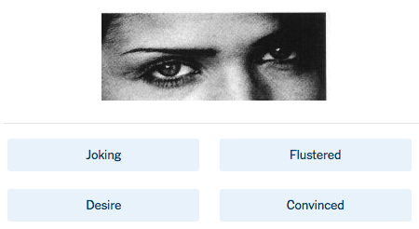
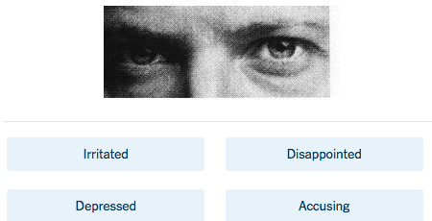
Discussion Questions:

- Which ways of knowing are primarily involved in determining your answers?

- Are you more likely to be correct if you respond to these questions intuitively or through careful deliberation?

- If you do well on this test, does that mean that you are good at reading people’s emotions in a meaningful, real-life way?

